Options under "Refine your search" aren't working
I was looking for records in Nebraska within a range of dates. When I try to check the box for the year of record, I get an error message stating that I have found a previously undiscovered problem. I had already refined the location using the state/province filter and the scientific name filter. It didn't seem to matter which species I was looking for, though I did not attempt to look with no filter or in a different state.

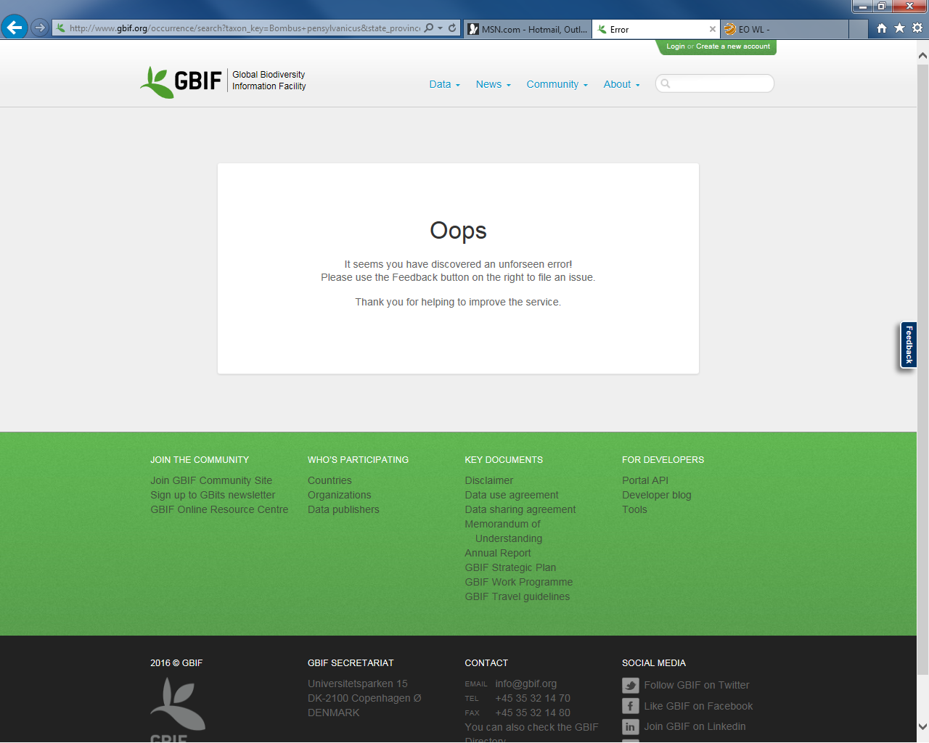
This is the error message I received.
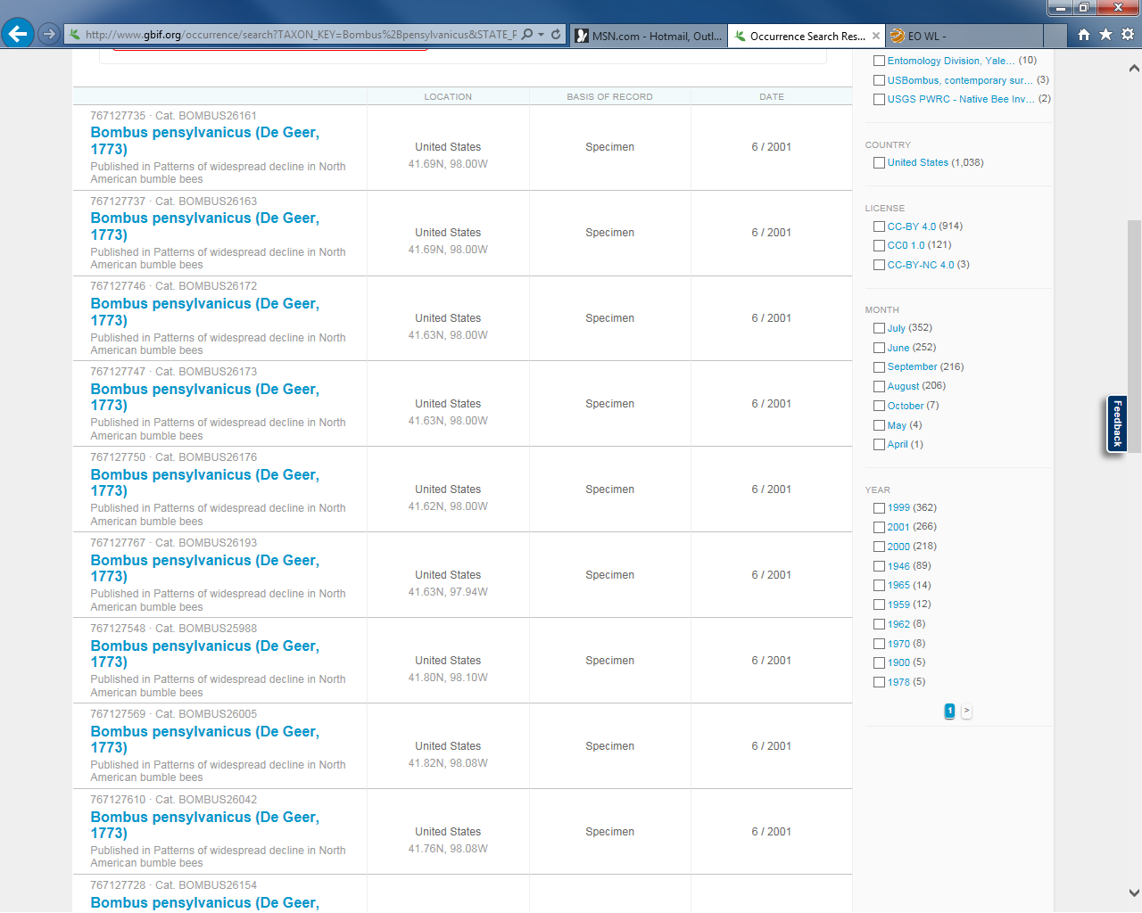
I tried to check a box in the red oval and received the error message on the previous page.

